**Spring Core and Maven**

**Exercise 1: Configuring a Basic Spring Application**

**Scenario:**

Your company is developing a web application for managing a library. You need to use the Spring Framework to handle the backend operations.

**Steps:**

**1. Set Up a Spring Project:**

* + Create a Maven project named LibraryManagement.
  + Add Spring Core dependencies in the pom.xml file.

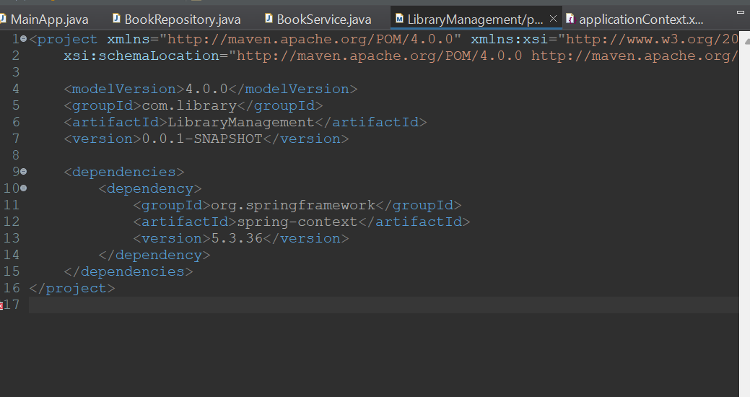

**2. Configure the Application Context:**

* + Create an XML configuration file named applicationContext.xml in the src/main/resources directory.
  + Define beans for BookService and BookRepository in the XML file.

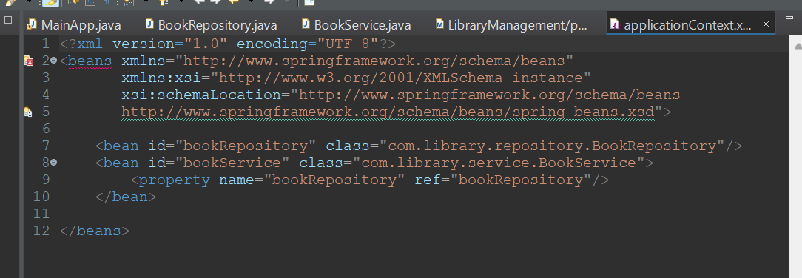

**3**. **Define Service and Repository Classes:**

* + Create a package **com.library.service** and add a class **BookService**.
  + Create a package **com.library.repository** and add a class **BookRepository**.

**4. Run the Application:**

* + Create a main class to load the Spring context and test the configuration.

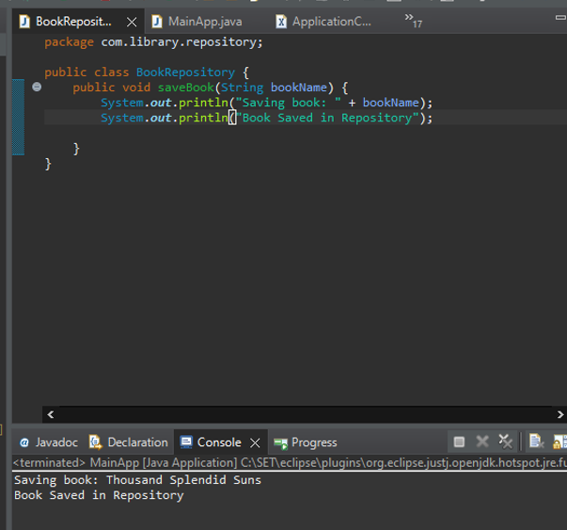

**Exercise 2: Implementing Dependency Injection**

**Scenario:**

In the library management application, you need to manage the dependencies between the BookService and BookRepository classes using Spring's IoC and DI.

Steps:

1. **Modify the XML Configuration:**
   * Update applicationContext.xml to wire BookRepository into BookService.

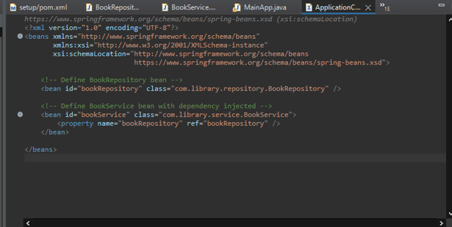

**2. Update the BookService Class:**

* + Ensure that BookService class has a setter method for BookRepository.

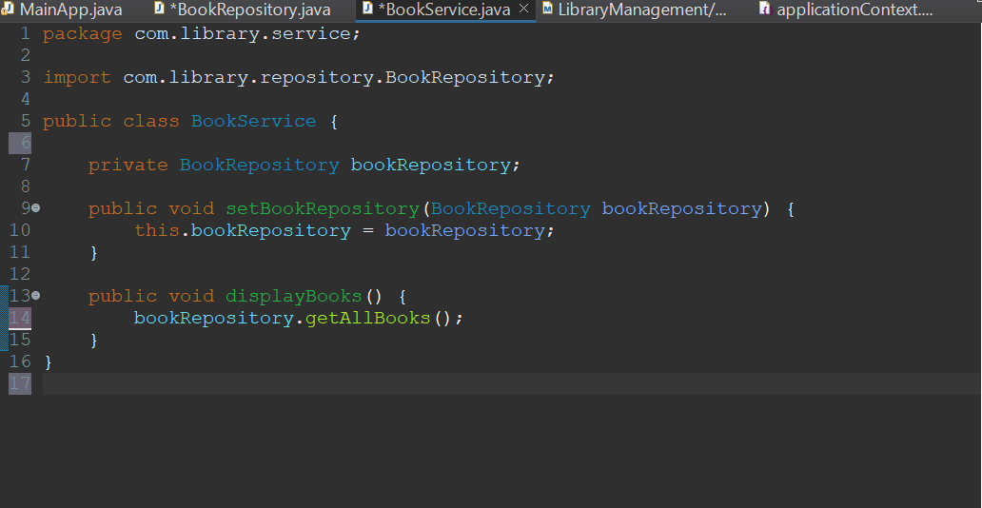

**3.Test the Configuration:**

* + Run the LibraryManagementApplication main class to verify the dependency injection.

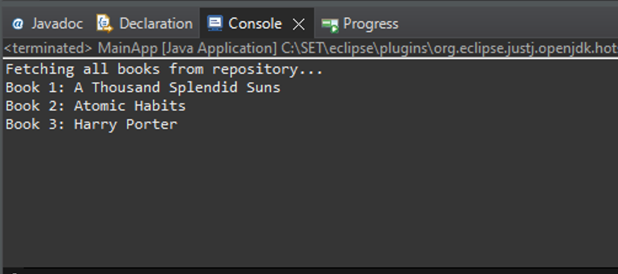

**Exercise 4: Creating and Configuring a Maven Project**

**Scenario:**

You need to set up a new Maven project for the library management application and add Spring dependencies.

**Steps:**

1. **Create a New Maven Project:**
   * Create a new Maven project named LibraryManagement.
2. **Add Spring Dependencies in pom.xml:**
   * Include dependencies for Spring Context, Spring AOP, and Spring WebMVC.
3. **Configure Maven Plugins:**
   * Configure the Maven Compiler Plugin for Java version 1.8 in the pom.xml file.

